# Name: Apurba Koirala

# Reg no: 22BCE3799

# Subject Code: BCSE302P

# Course Title: Database Systems

# Lab Slot: L33 + L34

# Guided by: Dr. Shashank Mouli Satapathy

# Question Number 1.

Create the above schema and insert the given data

Queries:

 CREATE TABLE EMPLOYEE(

    FName VARCHAR(15),

     MName CHAR(2),

    LName VARCHAR(15),

    SSN CHAR(9),

    BDate DATE,

    Address VARCHAR(50),

    Sex CHAR(1),

    Salary NUMBER(7),

    SuperSSN CHAR(9),

   DepNo NUMBER(5)

   );

CREATE TABLE PROJECT(

    PName VARCHAR(15),

    PNumber NUMBER(5),

    PLocation VARCHAR(15),

    DepNo NUMBER(5)

    );

 CREATE TABLE DEPARTMENT(

    DName VARCHAR(15),

    DepNo NUMBER(5),

    MgrSSN CHAR(9),

    MgrStartDate DATE

    );

OUTPUT:

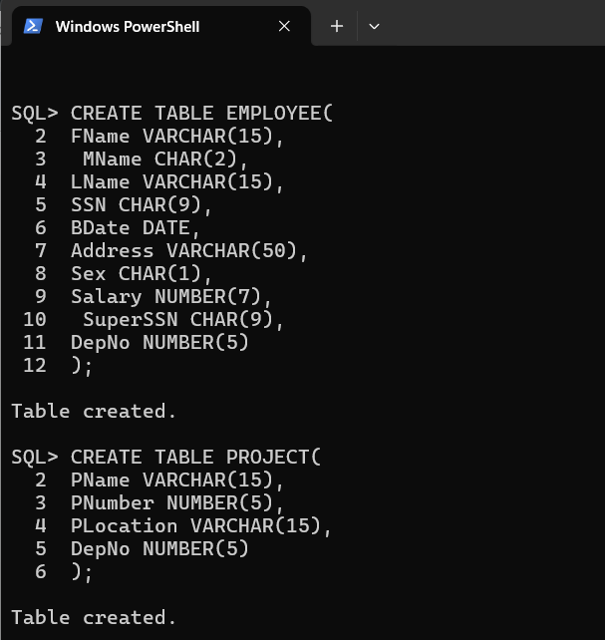  
  
  
  
  
  
  
  
  
  
  
  
  
  
  
  
  
  
  
  
  
  
  
  
  
  
  
  
  
  
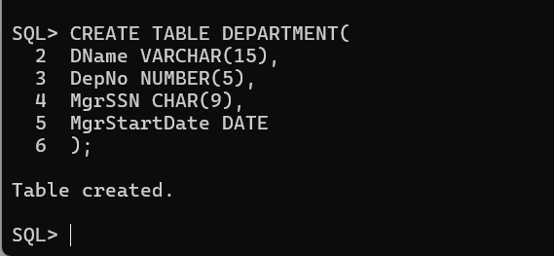

1) Insert the data given above in both employee, department and project tables.

For Employee

Queries:

INSERT INTO EMPLOYEE (FName, MName, LName, SSN, BDate, Address, Sex, Salary, SuperSSN, DepNo) VALUES ('Doug', 'E',

'Gilbert', '554433221', TO_DATE('09-JUN-60', 'DD-MON-RR'), '11 S 59 E, Salt Lake City, UT', 'M', 80000, NULL, 3);

INSERT INTO EMPLOYEE (FName, MName, LName, SSN, BDate, Address, Sex, Salary, SuperSSN, DepNo) VALUES ('Joyce', 'P', 'AN', '543216789', TO_DATE('07-FEB-78', 'DD-MON-RR'), '35 S 18 E, Salt Lake City, UT', 'F', 70000, NULL, 2);

INSERT INTO EMPLOYEE (FName, MName, LName, SSN, BDate, Address, Sex, Salary, SuperSSN, DepNo) VALUES ('Franklin', 'T', 'Wong', '333445555', TO_DATE('08-DEC-45', 'DD-MON-RR'), '638 Voss, Houston, TX', 'M', 40000, '554433221', 5);

INSERT INTO EMPLOYEE (FName, MName, LName, SSN, BDate, Address, Sex, Salary, SuperSSN, DepNo) VALUES ('Jennifer', 'S', 'Wallace', '987654321', TO_DATE('20-JUN-31', 'DD-MON-RR'), '291 Berry, Bellaire, TX', 'F', 43000, '554433221', 4);

INSERT INTO EMPLOYEE (FName, MName, LName, SSN, BDate, Address, Sex, Salary, SuperSSN, DepNo) VALUES ('John', 'B', 'Smith', '123456789', TO_DATE('09-JAN-55', 'DD-MON-RR'), '731 Fondren, Houston, TX', 'M', 30000, '333445555', 5);

INSERT INTO EMPLOYEE (FName, MName, LName, SSN, BDate, Address, Sex, Salary, SuperSSN, DepNo) VALUES ('Ramesh', 'K', 'Narayan', '666884444', TO_DATE('15-SEP-52', 'DD-MON-RR'), '975 Fire Oak, Humble, TX', 'M', 38000, '333445555', 5);

INSERT INTO EMPLOYEE (FName, MName, LName, SSN, BDate, Address, Sex, Salary, SuperSSN, DepNo) VALUES ('Joyce', 'A', 'English', '453453453', TO_DATE('31-JUL-62', 'DD-MON-RR'), '501 Rice, Houston, TX', 'F', 25000, '333445555', 5);

INSERT INTO EMPLOYEE (FName, MName, LName, SSN, BDate, Address, Sex, Salary, SuperSSN, DepNo) VALUES ('James', 'E', 'Borg', '888665555', TO_DATE('10-NOV-27', 'DD-MON-RR'), '450 Stone, Houston, TX', 'M', 55000, '543216789', 1);

INSERT INTO EMPLOYEE (FName, MName, LName, SSN, BDate, Address, Sex, Salary, SuperSSN, DepNo) VALUES ('Alicia', 'J', 'Zelaya', '987987777', TO_DATE('19-JUL-58', 'DD-MON-RR'), '3321 Castle, Spring, TX', 'F', 25000, '987654321', 4);

INSERT INTO EMPLOYEE (FName, MName, LName, SSN, BDate, Address, Sex, Salary, SuperSSN, DepNo) VALUES ('Ahmad', 'V', 'Jabbar', '987987987', TO_DATE('29-MAR-59', 'DD-MON-RR'), '980 Dallas, Houston, TX', 'M', 25000, '987654321', 4);

Output: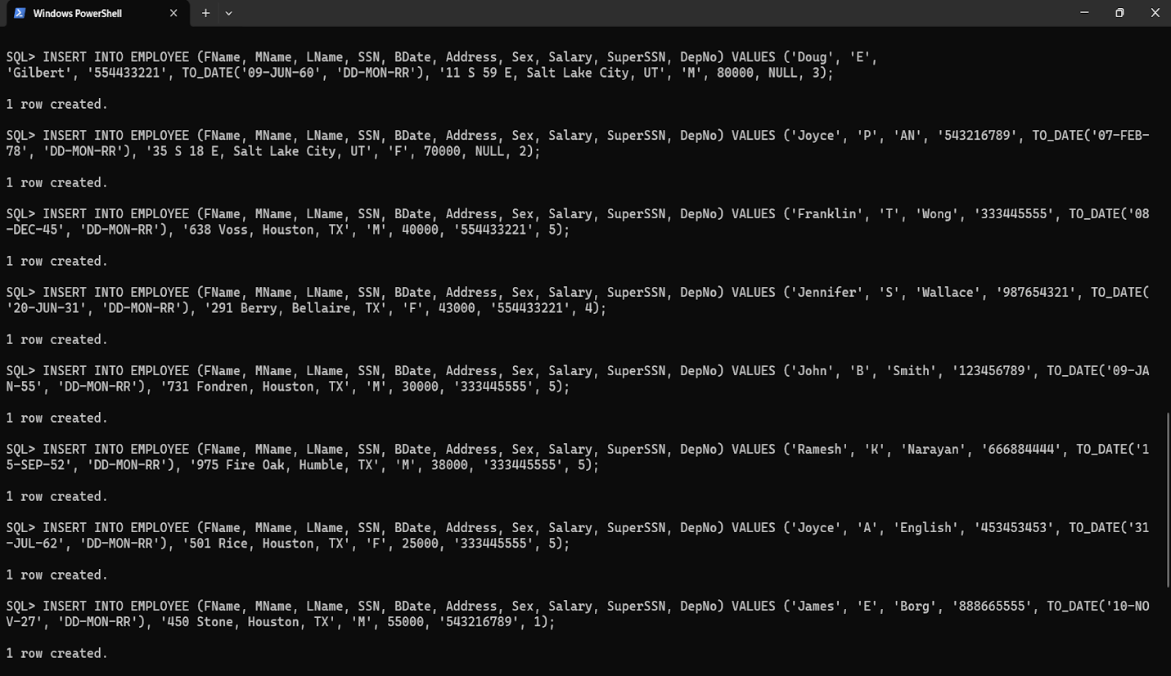

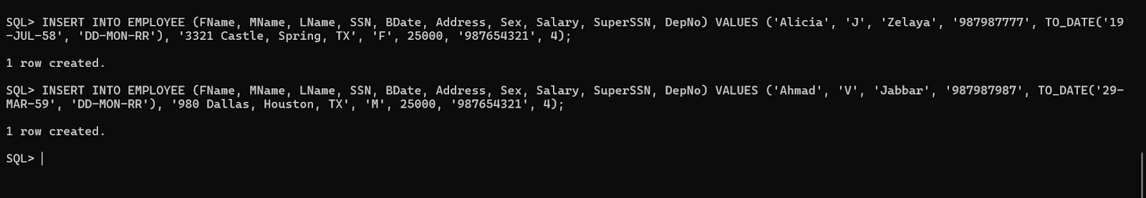

For Department

Queries:

INSERT INTO DEPARTMENT (DName, DepNo, MgrSSN, MgrStartDate)  VALUES ('Manufacture', 1, '888665555', TO_DATE('19-JUN-71', 'DD-MON-RR'));

INSERT INTO DEPARTMENT (DName, DepNo, MgrSSN, MgrStartDate)  VALUES ('Administration', 2, '543216789', TO_DATE('04-JAN-99', 'DD-MON-RR'));

INSERT INTO DEPARTMENT (DName, DepNo, MgrSSN, MgrStartDate)  VALUES ('Headquarter', 3, '554433221', TO_DATE('22-SEP-55', 'DD-MON-RR'));

INSERT INTO DEPARTMENT (DName, DepNo, MgrSSN, MgrStartDate)  VALUES ('Finance', 4, '987654321', TO_DATE('01-JAN-85', 'DD-MON-RR'));

INSERT INTO DEPARTMENT (DName, DepNo, MgrSSN, MgrStartDate)  VALUES ('Research', 5, '333445555', TO_DATE('22-MAY-78', 'DD-MON-RR'));

Output: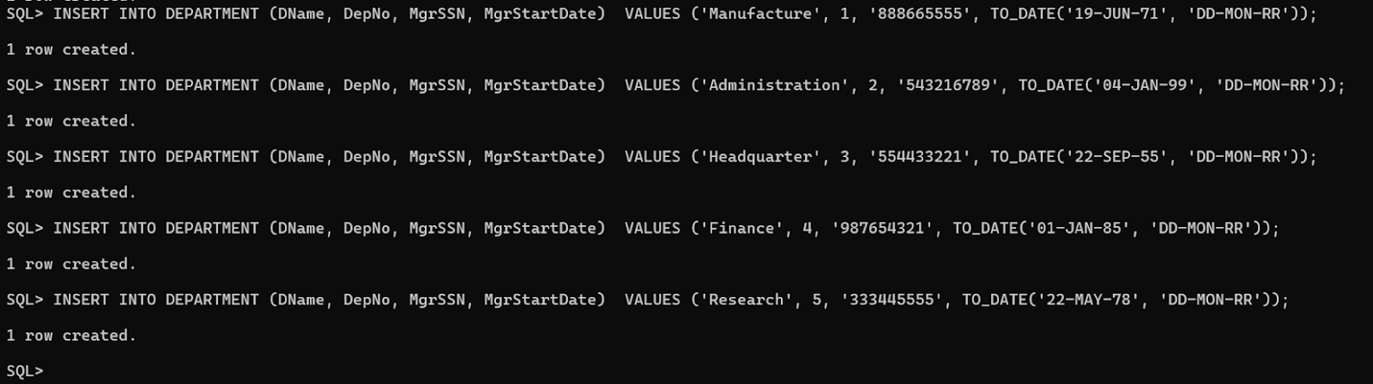

For Projects

Queries:

INSERT INTO Project (PName, PNumber, PLocation, DepNo)

VALUES ('ProjectA', 3388, 'Houston', 1);

INSERT INTO Project (PName, PNumber, PLocation, DepNo)

VALUES ('ProjectB', 1945, 'Salt Lake City', 2);

INSERT INTO Project (PName, PNumber, PLocation, DepNo)

VALUES ('ProjectC', 6688, 'Houston', 5);

INSERT INTO Project (PName, PNumber, PLocation, DepNo)

VALUES ('ProjectD', 2423, 'Bellaire', 4);

INSERT INTO Project (PName, PNumber, PLocation, DepNo)

VALUES ('ProjectE', 4765, 'Sugarland', 4);

INSERT INTO Project (PName, PNumber, PLocation, DepNo)

VALUES ('ProjectF', 1564, 'Salt Lake City', 2);

INSERT INTO Project (PName, PNumber, PLocation, DepNo)

VALUES ('ProjectG', 1234, 'New York', 3);

INSERT INTO Project (PName, PNumber, PLocation, DepNo)

VALUES ('ProjectH', 3467, 'Stafford', 4);

INSERT INTO Project (PName, PNumber, PLocation, DepNo)

VALUES ('ProjectI', 3445, 'Chicago', 4);

INSERT INTO Project (PName, PNumber, PLocation, DepNo)

VALUES ('ProjectJ', 2212, 'San Francisco', 2);

Output: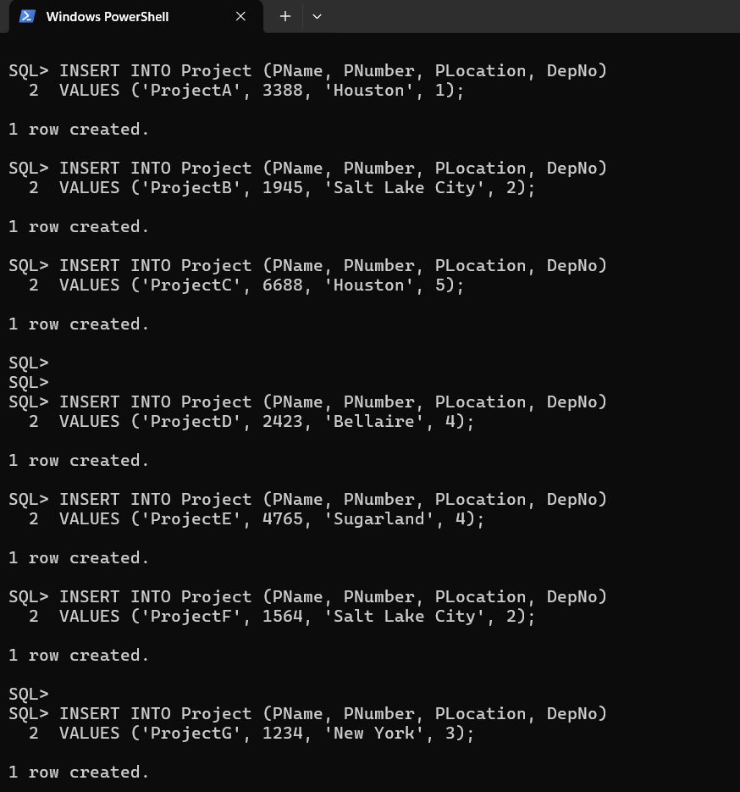

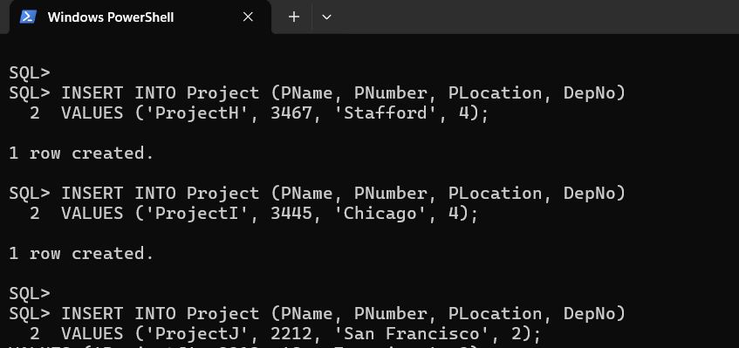

2) Display all the employees’ information.

Queries:

SELECT * FROM EMPLOYEE;

Output:

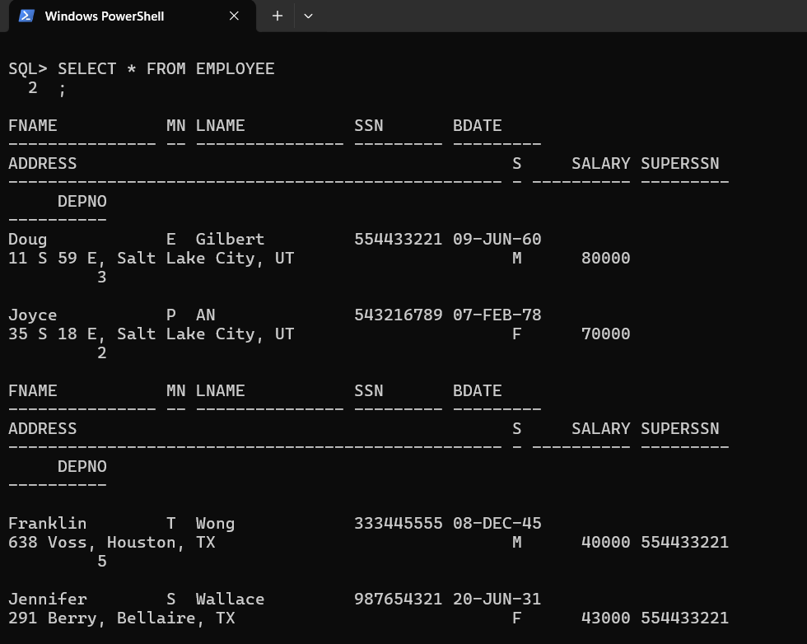  
  
  
  
  
  
  
  
  
  
  
  
  
  
  
  
  
  
  
  
  
  
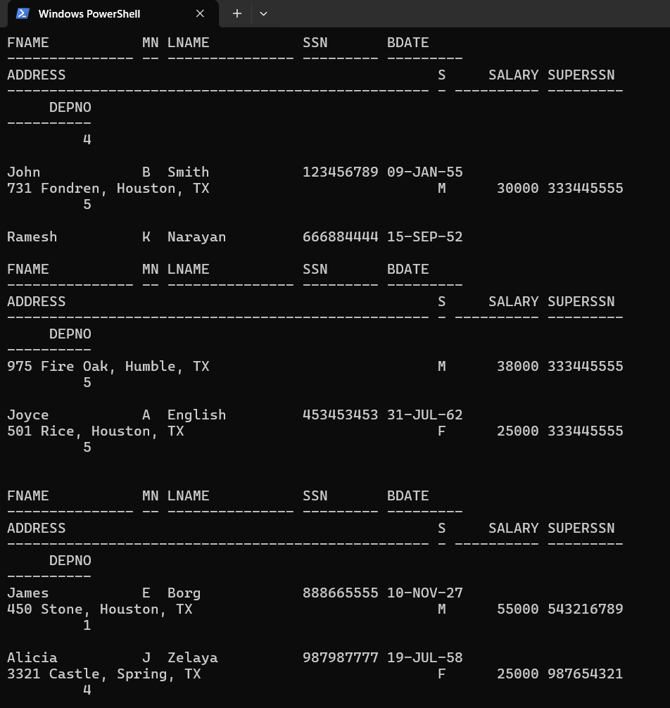  
  
  
  
  
  
  
  
  
  
  
  
  
  
  
3) Display Employee name along with his SSN and Supervisor SSN.

Queries:

SELECT FName, LName, SSN, SuperSSN FROM Employee;

Output: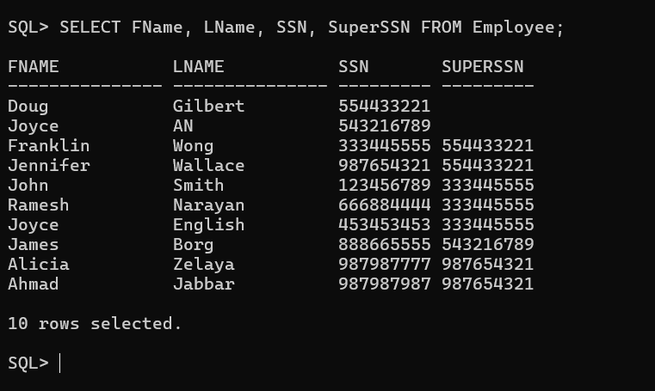

4) Display the employee names whose bdate is ’29-MAR-1959’.

Queries:

SELECT FName, LName FROM Employee WHERE BDate = TO_DATE('29-MAR-59', 'DD-MON-RR');

Output:

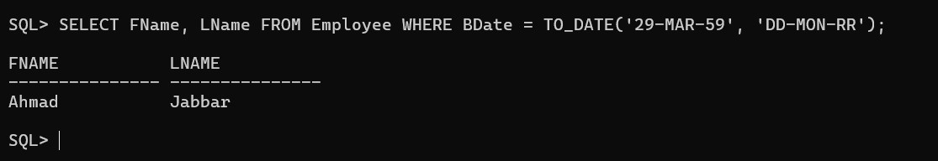

5) Display salary of the employees without duplications.

Queries:

SELECT DISTINCT Salary FROM Employee;

Output: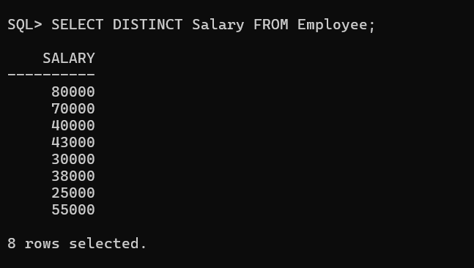

6) Display the MgrSSN, MgrStartDate of the manager of ‘Finance’ department.

Queries:

SELECT MgrSSN, MgrStartDate FROM DEPARTMENT WHERE DName = 'Finance';

Output:

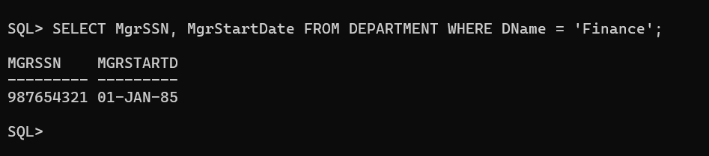

7) Modify the department number of an employee having fname as ‘Joyce’ to 5

Queries:

UPDATE EMPLOYEE SET DepNo = 5 WHERE FName = 'Joyce';

Output:

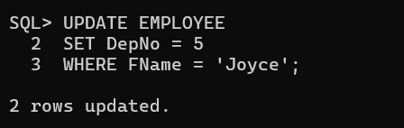

8) Alter Table department add column DepartmentPhoneNum of NUMBER data type

and insert values into this column only. Add Not Null constraint to the column.

Queries:

ALTER TABLE department

ADD DepartmentPhoneNum NUMBER;

UPDATE department

SET DepartmentPhoneNum = CASE DEPNO

    WHEN 1 THEN 1234567890

    WHEN 2 THEN 2345678901

    WHEN 3 THEN 3456789012

    WHEN 4 THEN 4567890123

    WHEN 5 THEN 5678901234

END;

ALTER TABLE department

MODIFY DepartmentPhoneNum NUMBER NOT NULL;

Output:

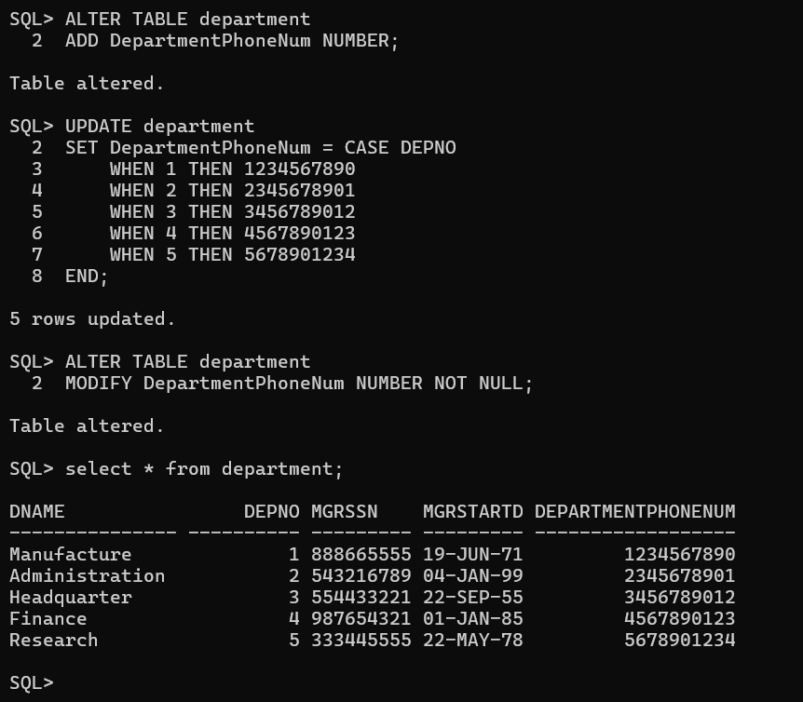

9) Alter table orders modify the size of DepartmentPhoneNum.

Queries:

ALTER TABLE DEPARTMENT ADD DeptPhoneNum_New NUMBER(38);

UPDATE DEPARTMENT SET DeptPhoneNum_New = DepartmentPhoneNum;

ALTER TABLE DEPARTMENT DROP COLUMN DepartmentPhoneNum;

ALTER TABLE DEPARTMENT RENAME COLUMN DeptPhoneNum_New TO DepartmentPhoneNum;

Output:

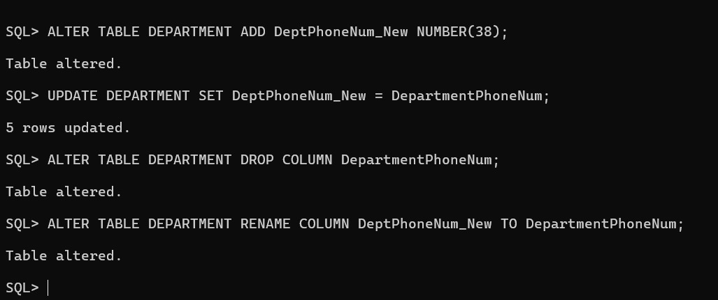

10) Modify the field name DepartmentPhoneNum of departments table to PhNo.

Queries:

ALTER TABLE department RENAME COLUMN DepartmentPhoneNum TO PhNo;

Output:

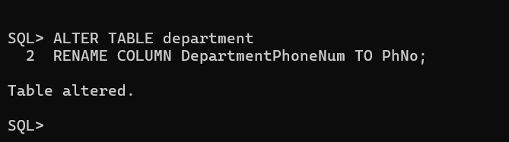

11) Rename Table Department as DEPT.

Queries:

ALTER TABLE Department RENAME TO DEPT;

Output:

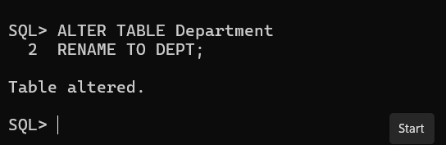

12) Alter Table department remove column DepartmentPhoneNum

Queries:

ALTER TABLE DEPT DROP COLUMN PhNo;

Output:

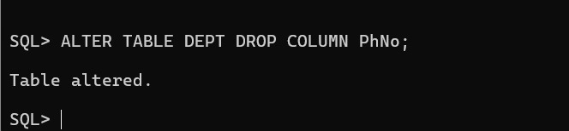

# Question Number 2.

Modify the schema given in Exercise-1 to incorporate the new relations and add the constraints to all the relations as mentioned above.

For schema:

Queries:

EMPLOYEE TABLE

ALTER TABLE EMPLOYEE

ADD CONSTRAINT UQ_SSN UNIQUE (SSN);

ALTER TABLE EMPLOYEE

ADD CONSTRAINT FK_SuperSSN FOREIGN KEY (SuperSSN) REFERENCES EMPLOYEE(SSN) ON DELETE SET NULL;

 ALTER TABLE EMPLOYEE

 MODIFY Sex CHAR(1) CHECK (Sex IN ('M', 'F', 'm', 'f')) NOT NULL;

ALTER TABLE EMPLOYEE

MODIFY Salary NUMBER(7) DEFAULT 800;

ALTER TABLE DEPT

ADD CONSTRAINT UQ_DepNo UNIQUE (DepNo);

ALTER TABLE EMPLOYEE

ADD CONSTRAINT FK_DepNo FOREIGN KEY (DepNo) REFERENCES DEPT(DepNo) ON DELETE CASCADE;

ALTER TABLE EMPLOYEE

MODIFY FName VARCHAR(15) NOT NULL;

ALTER TABLE EMPLOYEE

MODIFY LName VARCHAR(15) NOT NULL;

OUTPUT:

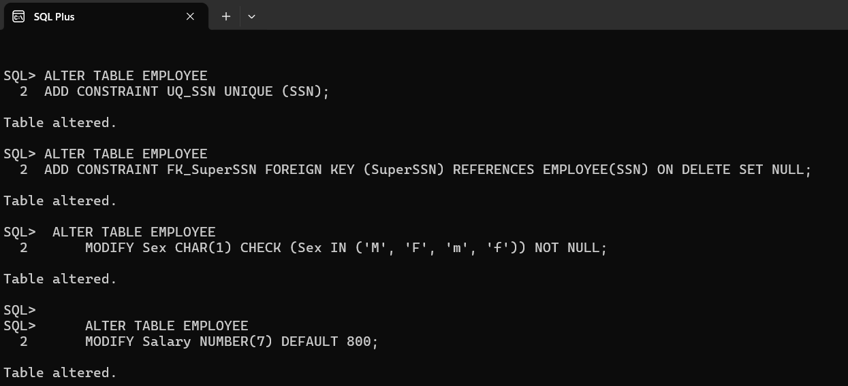

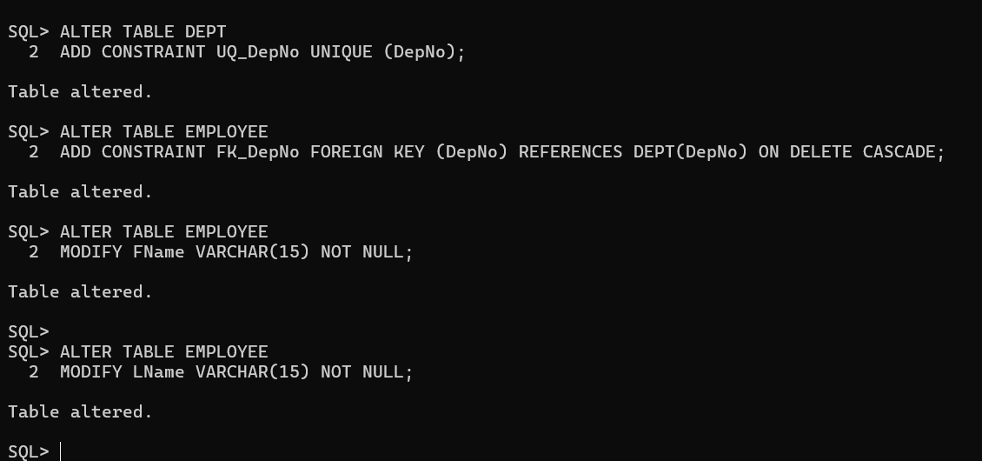

Queries:

DEPARTMENT TABLE

ALTER TABLE DEPT

MODIFY DName VARCHAR(15) NOT NULL;

ALTER TABLE DEPT

ADD CONSTRAINT FK_MgrSSN FOREIGN KEY (MgrSSN) REFERENCES EMPLOYEE(SSN) ON DELETE SET NULL;

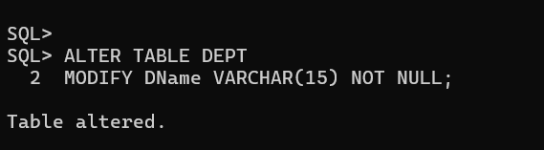

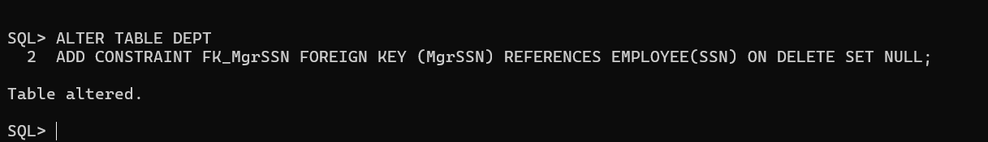

Queries:

PROJECT TABLE

ALTER TABLE PROJECT

MODIFY PName VARCHAR(15) NOT NULL;

ALTER TABLE PROJECT

ADD CONSTRAINT PNUMBER PRIMARY KEY (PNUMBER);

ALTER TABLE PROJECT

ADD CONSTRAINT FK_DepNo_Project FOREIGN KEY (DepNo) REFERENCES DEPT(DepNo) ON DELETE SET NULL;

OUTPUT:

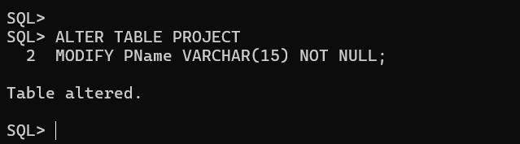

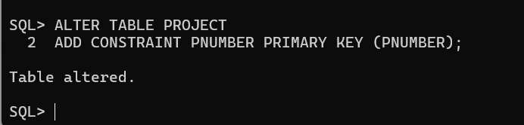

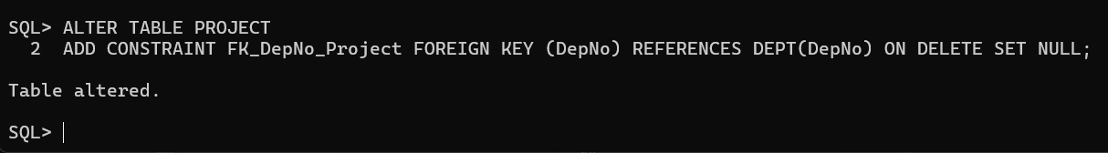

QUERIES

CREATING NEW TABLES:

CREATE TABLE Dept_Locations (

    DepNo NUMBER(5),

    DLocation VARCHAR(15),

    CONSTRAINT FK_DepNo_Locations FOREIGN KEY (DepNo) REFERENCES DEPT(DepNo) ON DELETE CASCADE

);

CREATE TABLE Works_On (

  ESSN CHAR(9),

  PNumber NUMBER(5),

  Hours NUMBER(3,1) NOT NULL,

  PRIMARY KEY (ESSN, PNumber),

  CONSTRAINT FK_Work_Emp FOREIGN KEY (ESSN) REFERENCES EMPLOYEE(SSN) ON DELETE CASCADE,

  CONSTRAINT FK_Work_Proj FOREIGN KEY (PNumber) REFERENCES PROJECT(PNumber) ON DELETE CASCADE

);

CREATE TABLE Dependent (

    ESSN CHAR(9),

    DependentName VARCHAR2(15),

    Sex CHAR(1) CHECK (Sex IN ('M', 'F', 'm', 'f')),

    BDate DATE,

    Relationship VARCHAR2(8),

    PRIMARY KEY (ESSN, DependentName),

    CONSTRAINT FK_Dep_Emp FOREIGN KEY (ESSN) REFERENCES EMPLOYEE(SSN) ON DELETE CASCADE

);

INSERT INTO Dept_Locations (DepNo, DLocation) VALUES (1, 'Houston');

INSERT INTO Dept_Locations (DepNo, DLocation) VALUES (1, 'Chicago');

INSERT INTO Dept_Locations (DepNo, DLocation) VALUES (2, 'New York');

INSERT INTO Dept_Locations (DepNo, DLocation) VALUES (2, 'San Francisco');

INSERT INTO Dept_Locations (DepNo, DLocation) VALUES (3, 'Salt Lake City');

INSERT INTO Dept_Locations (DepNo, DLocation) VALUES (4, 'Stafford');

INSERT INTO Dept_Locations (DepNo, DLocation) VALUES (4, 'Bellaire');

INSERT INTO Dept_Locations (DepNo, DLocation) VALUES (4, 'Sugarland');

INSERT INTO Dept_Locations (DepNo, DLocation) VALUES (5, 'Houston');

INSERT INTO Works_On (ESSN, PNumber, Hours) VALUES ('123456789', 3388, 32.5);

INSERT INTO Works_On (ESSN, PNumber, Hours) VALUES ('123456789', 1945, 7.5);

INSERT INTO Works_On (ESSN, PNumber, Hours) VALUES ('666884444', 1945, 40.0);

INSERT INTO Works_On (ESSN, PNumber, Hours) VALUES ('453453453', 1945, 20.0);

INSERT INTO Works_On (ESSN, PNumber, Hours) VALUES ('453453453', 3445, 20.0);

INSERT INTO Works_On (ESSN, PNumber, Hours) VALUES ('333445555', 6688, 10.0);

INSERT INTO Works_On (ESSN, PNumber, Hours) VALUES ('333445555', 3467, 10.0);

INSERT INTO Works_On (ESSN, PNumber, Hours) VALUES ('987654321', 2423, 20.0);

INSERT INTO Works_On (ESSN, PNumber, Hours) VALUES ('987987987', 2212, 13.0);

INSERT INTO Works_On (ESSN, PNumber, Hours) VALUES ('554433221', 1945, 21.5);

INSERT INTO Dependent (ESSN, DependentName, Sex, BDate, Relationship)

VALUES ('333445555', 'Alice', 'F', TO_DATE('05-APR-76', 'DD-MON-RR'), 'Daughter');

INSERT INTO Dependent (ESSN, DependentName, Sex, BDate, Relationship)

VALUES ('333445555', 'Theodore', 'M', TO_DATE('25-OCT-73', 'DD-MON-RR'), 'Son');

INSERT INTO Dependent (ESSN, DependentName, Sex, BDate, Relationship)

VALUES ('987654321', 'Joy', 'F', TO_DATE('03-MAY-78', 'DD-MON-RR'), 'Spouse');

INSERT INTO Dependent (ESSN, DependentName, Sex, BDate, Relationship)

VALUES ('987654321', 'Ahmad', 'M', TO_DATE('31-DEC-85', 'DD-MON-RR'), 'Spouse');

INSERT INTO Dependent (ESSN, DependentName, Sex, BDate, Relationship)

VALUES ('123456789', 'Elizabeth', 'F', TO_DATE('05-MAY-57', 'DD-MON-RR'), 'Spouse');

OUTPUT:

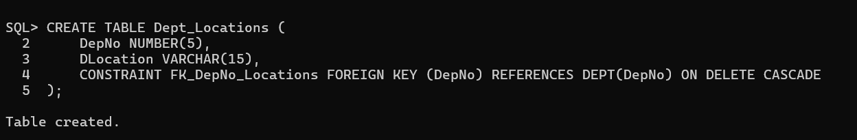

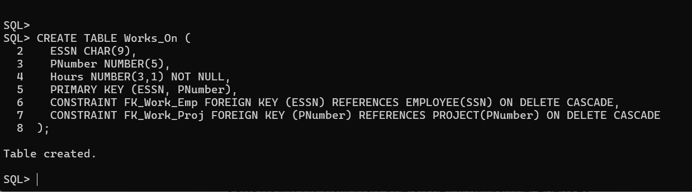

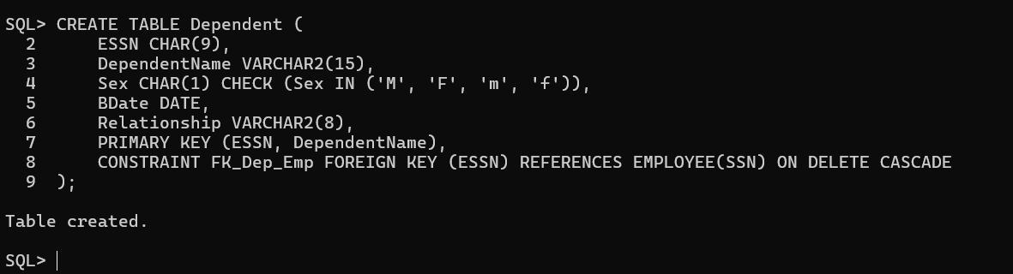

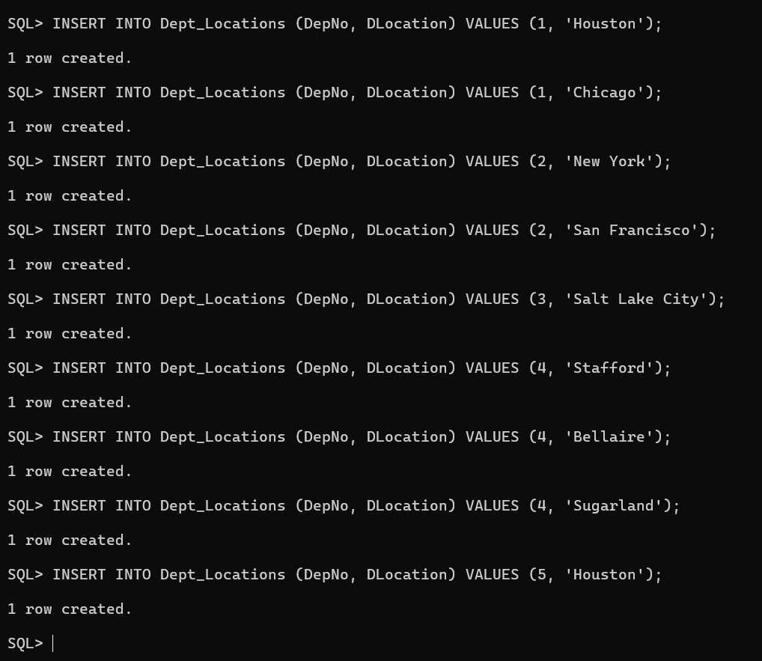

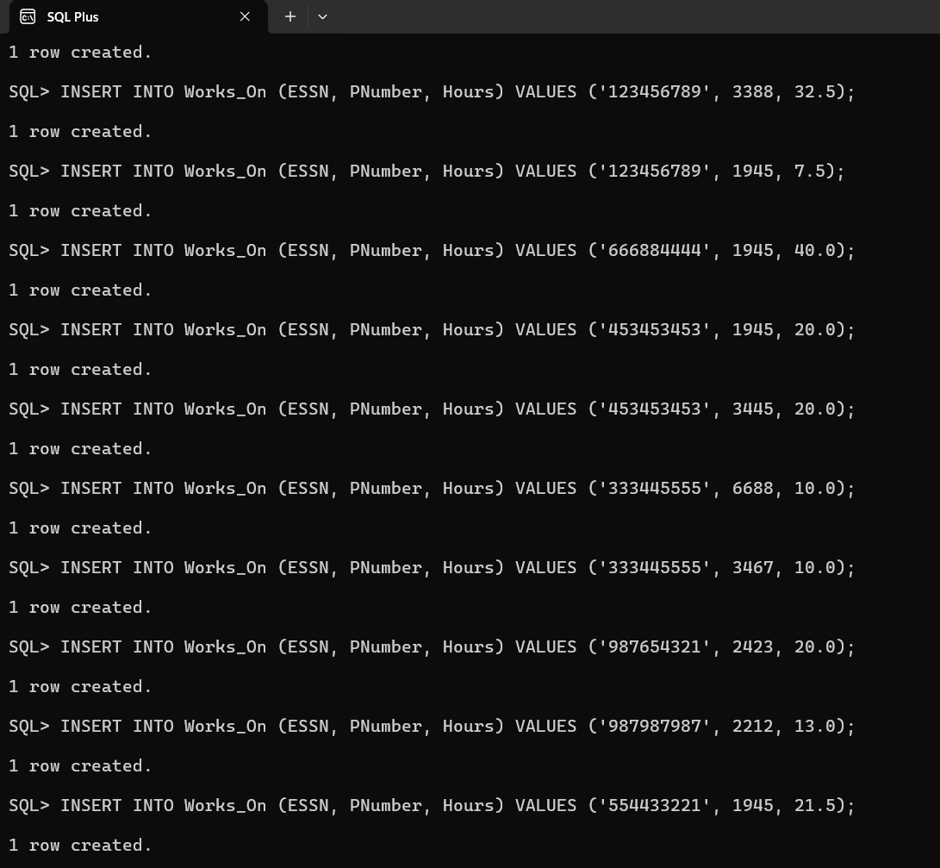

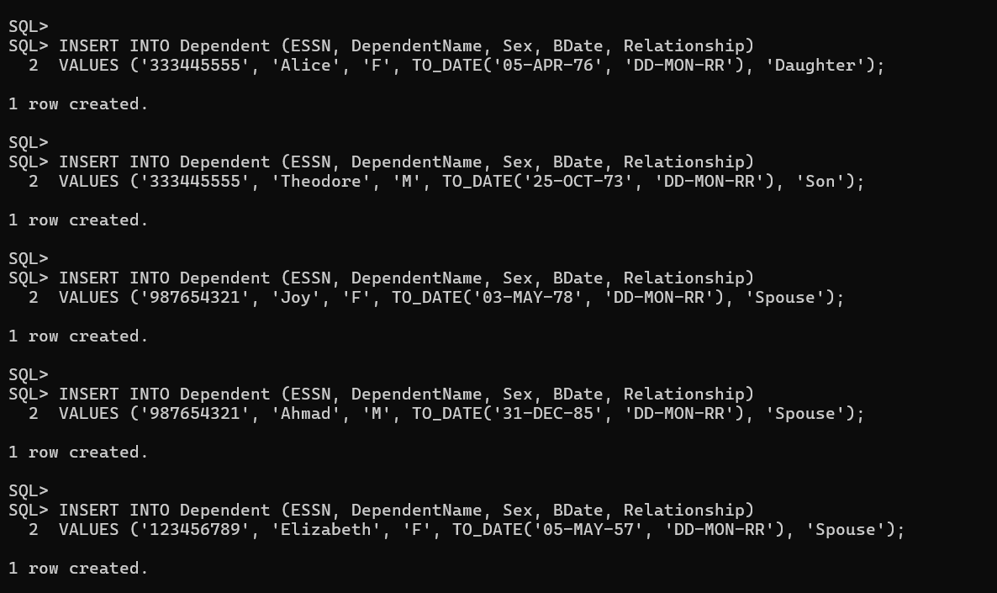

Execute the following Query on the DB to display and discuss the integrity constraints violated by any of the following operations

1) Insert ('Robert', 'F', 'Scott', '943775543', '21-JUN-42', '2365 Newcastle Rd, Bellaire, TX', M, 58000, '888665555', 1 ) into EMPLOYEE.

Queries:

INSERT INTO EMPLOYEE (FName, MName, LName, SSN, BDate, Address, Sex, Salary, SuperSSN, DepNo)

   VALUES ('Robert', 'F', 'Scott', '943775543', TO_DATE('21-JUN-42', 'DD-MON-RR'), '2365 Newcastle Rd, Bellaire, TX', 'M', 58000, '888665555', 1);

Output:

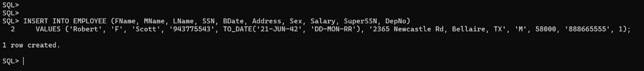

NOTE:

This will succeed if 888665555 exists in the SSN of EMPLOYEE because SuperSSN references SSN with the ON DELETE SET NULL option. If 888665555 is absent, SuperSSN will be set to NULL.

2) Insert ( '677678989', null, '40.0' ) into WORKS_ON.

Queries:

 INSERT INTO WORKS_ON (ESSN, PNumber, Hours)

   VALUES ('677678989', NULL, '40.0');

Output:

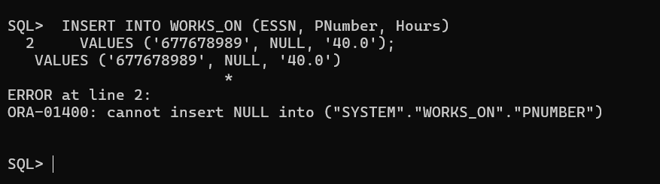

NOTE:

 This will fail due to NULL in PNumber, which violates the foreign key constraint that references PNumber in the PROJECT table.

3) Insert ( '453453453', 'John', M, '12-DEC-60', 'SPOUSE' ) into DEPENDENT

Queries:

 INSERT INTO DEPENDENT (ESSN, DependentName, Sex, BDate, Relationship)

   VALUES ('453453453', 'John', 'M', TO_DATE('12-DEC-60', 'DD-MON-RR'), 'SPOUSE');

Output:

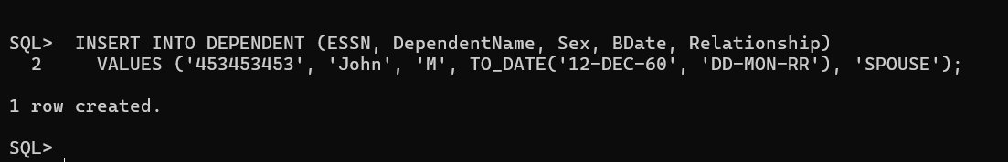

NOTE:

 This will succeed if 453453453 exists in SSN of EMPLOYEE and the Sex is valid per the CHECK constraint.

4) Delete the WORKS_ON tuples with ESSN= '333445555'.

Queries:

  DELETE FROM WORKS_ON WHERE ESSN = '333445555';

Output:

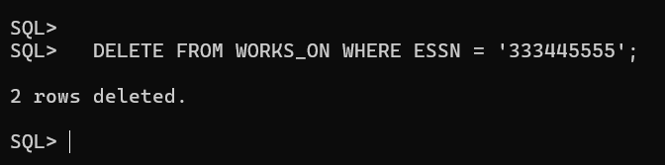

NOTE:

 This will delete all rows in WORKS_ON where ESSN = '333445555' due to the ON DELETE CASCADE on the foreign key constraint.

5) Modify the MGRSSN and MGRSTARTDATE of the DEPARTMENT tuple with DNUMBER=5 to '123456789' and '01-OCT-88', respectively. Alter the tables to

Queries:

 UPDATE DEPT

   SET MgrSSN = '123456789', MgrStartDate = TO_DATE('01-OCT-88', 'DD-MON-RR')

   WHERE DepNo = 5;

Output:

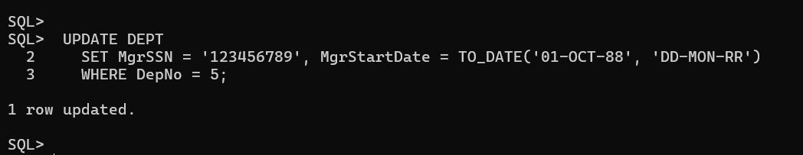

NOTE:

This will succeed if 123456789 exists in the EMPLOYEE table. If it does not exist, MgrSSN will be set to NULL because of the ON DELETE SET NULL constraint.

6) Add Foreign Keys using Alter Table [if not done earlier].

QUERIES:

ALTER TABLE EMPLOYEE

ADD CONSTRAINT FK_SuperSSN FOREIGN KEY (SuperSSN) REFERENCES EMPLOYEE(SSN) ON DELETE SET NULL;

ALTER TABLE EMPLOYEE

ADD CONSTRAINT FK_DepNo FOREIGN KEY (DepNo) REFERENCES DEPT(DepNo) ON DELETE CASCADE;

ALTER TABLE DEPT

ADD CONSTRAINT FK_MgrSSN FOREIGN KEY (MgrSSN) REFERENCES EMPLOYEE(SSN) ON DELETE SET NULL;

ALTER TABLE PROJECT

ADD CONSTRAINT FK_DepNo_Project FOREIGN KEY (DepNo) REFERENCES DEPT(DepNo) ON DELETE SET NULL;

OUTPUT:

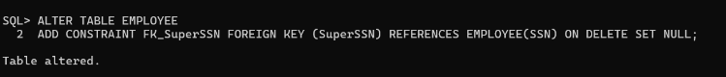

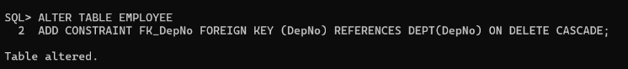





7) Drop Foreign key defined on SuperSSN and add it using Alter table command.

QUERIES:

ALTER TABLE EMPLOYEE DROP CONSTRAINT FK_SuperSSN;

ALTER TABLE EMPLOYEE ADD CONSTRAINT FK_SuperSSN FOREIGN KEY (SuperSSN) REFERENCES EMPLOYEE(SSN) ON DELETE SET NULL;

OUTPUT:

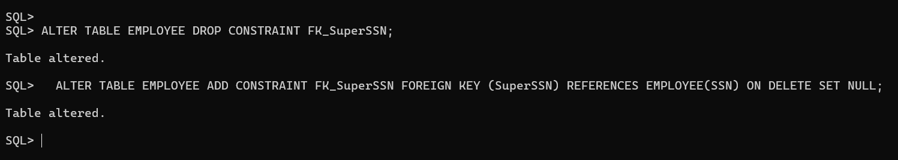

8) Add Unique constraint to the Project name attribute and not null to sex of employee.

QUERIES:

ALTER TABLE PROJECT

ADD CONSTRAINT UC_PName UNIQUE (PName);

ALTER TABLE EMPLOYEE

MODIFY Sex CHAR(1) NOT NULL;

OUTPUT:

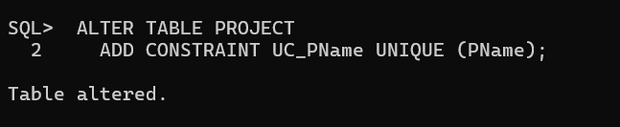

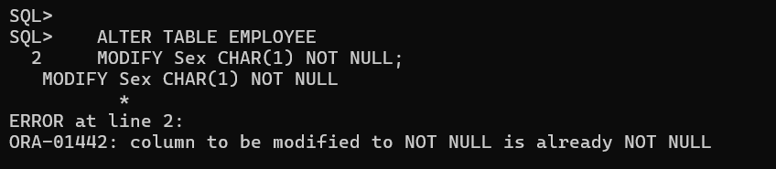

9) Make Address as a new type containing door no, street, city, State, Continent.

QUERIES:

CREATE TYPE Address_Type AS OBJECT (

    DoorNo NUMBER,

    Street VARCHAR2(50),

    City VARCHAR2(50),

    State VARCHAR2(50),

    Continent VARCHAR2(50)

);

/

ALTER TABLE Employee ADD Address Address;

OUTPUT:

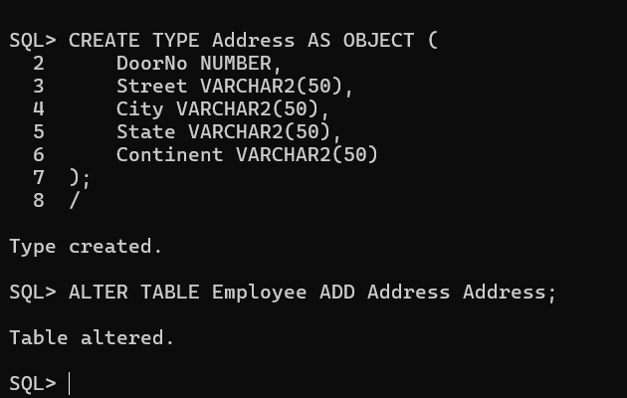

10) Make salary of employee to accept real values.

QUERIES:

ALTER TABLE EMPLOYEE

MODIFY Salary FLOAT;

OUTPUT:

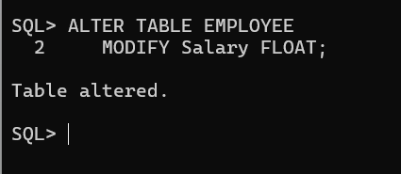

# Question Number 3.

Create a hospital database with the following entity and attributes

Physician

employeeid – this is a unique ID of a physician

name – this is the name of a physician

position – this is the designation of a physician (Surgeon, consultant etc)

ssn – this is a security number of a physician

Department

departmentid – this is a unique ID for a department

name – this is the name of a department

head – this is the ID of the physician who is the head of a department, referencing to the column employeeid of the table physician

Works_with

physician – this is the ID of the physicians which is referencing to the column employeeid of the physician table

department – this is the ID the department which is referencing to the column departmentid of the department table

primaryaffiliation – this is a logical column which indicate that whether the physicians are yet to be affiliated or not

Procedure

code – this is the unique ID of a medical procedure

name – the name of the medical procedure

cost – the cost for the procedure

Patient

ssn – this is a unique ID for each patient

name – this is the name of the patient

address – this is the address of the patient

phone – this is the phone number of the patient

insuranceid – this is the insurance id of the patient

pcp – this is the ID of the physician who primarily checked up the patient which is referencing to the column employeeid of the physician table

Nurse

employeeid – this is the unique ID for a nurse

name – name of the nurses

position – the designation of the nurses

registered – this is a logical column which indicate that whether the nurses are registered for nursing or not

ssn – this is the security number of a nurse

Appointment

appointmentid – this is the unique ID for an appointment

patient – this is the ID of each patient which is referencing to the ssn column of patient table

prepnurse – the ID of the nurse who may attend the patient with the physician, which is referencing to the column employeeid of the nurse table

physician – this is the ID the physicians which is referencing to the employeeid column of the physician table

date – date of appointment

start_time – this is the schedule date and approximate time to meet the physician  end_time – this is the schedule date and approximate time to end the meeting  examinationroom – this the room where to meet a patient to the physician

Insert required data into each relation (min. FIVE) and write down the queries in order to obtain the following information.

Queries For Schema and data input:

CREATE TABLE Physician (

    employeeid NUMBER PRIMARY KEY,

    name VARCHAR2(100),

    position VARCHAR2(50),

    ssn CHAR(9) UNIQUE

);

CREATE TABLE Department (

    departmentid NUMBER PRIMARY KEY,

    name VARCHAR2(100),

    head NUMBER,

    CONSTRAINT fk_dept_head FOREIGN KEY (head) REFERENCES Physician(employeeid)

);

CREATE TABLE Works_With (

    physician NUMBER,

    department NUMBER,

    primaryaffiliation CHAR(1),

    CONSTRAINT pk_works_with PRIMARY KEY (physician, department),

    CONSTRAINT fk_works_physician FOREIGN KEY (physician) REFERENCES Physician(employeeid),

    CONSTRAINT fk_works_department FOREIGN KEY (department) REFERENCES Department(departmentid)

);

CREATE TABLE Procedure (

    code NUMBER PRIMARY KEY,

    name VARCHAR2(100),

    cost NUMBER(10, 2)

);

CREATE TABLE Patient (

    ssn CHAR(9) PRIMARY KEY,

    name VARCHAR2(100),

    address VARCHAR2(255),

    phone VARCHAR2(15),

    insuranceid VARCHAR2(50),

    pcp NUMBER,

    CONSTRAINT fk_patient_pcp FOREIGN KEY (pcp) REFERENCES Physician(employeeid)

);

CREATE TABLE Nurse (

    employeeid NUMBER PRIMARY KEY,

    name VARCHAR2(100),

    position VARCHAR2(50),

    registered CHAR(1),

    ssn CHAR(9) UNIQUE

);

CREATE TABLE Appointment (

    appointmentid NUMBER PRIMARY KEY,

    patient CHAR(9),

    prepnurse NUMBER,

    physician NUMBER,

    appt_date DATE,

    start_time TIMESTAMP,

    end_time TIMESTAMP,

    examinationroom VARCHAR2(50),

    CONSTRAINT fk_appointment_patient FOREIGN KEY (patient) REFERENCES Patient(ssn),

    CONSTRAINT fk_appointment_prepnurse FOREIGN KEY (prepnurse) REFERENCES Nurse(employeeid),

    CONSTRAINT fk_appointment_physician FOREIGN KEY (physician) REFERENCES Physician(employeeid)

);

INSERT INTO Physician (employeeid, name, position, ssn) VALUES (1, 'Dr. Smith', 'Surgeon', '123456789');

INSERT INTO Physician (employeeid, name, position, ssn) VALUES (2, 'Dr. Johnson', 'Consultant', '987654321');

INSERT INTO Physician (employeeid, name, position, ssn) VALUES (3, 'Dr. Williams', 'General Practitioner', '456789123');

INSERT INTO Physician (employeeid, name, position, ssn) VALUES (4, 'Carol Smith', 'Pediatrician', '321654987');

INSERT INTO Physician (employeeid, name, position, ssn) VALUES (5, 'Carl Johnson', 'Orthopedic Surgeon', '654987321');

INSERT INTO Physician (employeeid, name, position, ssn) VALUES (6, 'Dr. Clark', 'Neurologist', '999999999');

INSERT INTO Department (departmentid, name, head) VALUES (1, 'Orthopedics', 5);

INSERT INTO Department (departmentid, name, head) VALUES (2, 'Pediatrics', 4);

INSERT INTO Department (departmentid, name, head) VALUES (3, 'General Medicine', 3);

INSERT INTO Department (departmentid, name, head) VALUES (4, 'Surgery', 1);

INSERT INTO Department (departmentid, name, head) VALUES (5, 'Consulting', 2);

INSERT INTO Works_With (physician, department, primaryaffiliation) VALUES (1, 4, 'Y');

INSERT INTO Works_With (physician, department, primaryaffiliation) VALUES (2, 5, 'Y');

INSERT INTO Works_With (physician, department, primaryaffiliation) VALUES (3, 3, 'N');

INSERT INTO Works_With (physician, department, primaryaffiliation) VALUES (4, 2, 'Y');

INSERT INTO Works_With (physician, department, primaryaffiliation) VALUES (5, 1, 'Y');

INSERT INTO Procedure (code, name, cost) VALUES (101, 'Physiotherapy', 150.00);

INSERT INTO Procedure (code, name, cost) VALUES (102, 'Gastric problem', 200.00);

INSERT INTO Procedure (code, name, cost) VALUES (103, 'X-Ray', 100.00);

INSERT INTO Procedure (code, name, cost) VALUES (104, 'Blood Test', 50.00);

INSERT INTO Procedure (code, name, cost) VALUES (105, 'MRI Scan', 500.00);

INSERT INTO Patient (ssn, name, address, phone, insuranceid, pcp) VALUES ('111223344', 'John Doe', '123 Elm St', '555-1234', 'INS12345', 1);

INSERT INTO Patient (ssn, name, address, phone, insuranceid, pcp) VALUES ('222334455', 'Jane Roe', '456 Oak St', '555-5678', 'INS67890', 2);

INSERT INTO Patient (ssn, name, address, phone, insuranceid, pcp) VALUES ('333445566', 'Alice Smith', '789 Pine St', '555-9101', 'INS54321', 3);

INSERT INTO Patient (ssn, name, address, phone, insuranceid, pcp) VALUES ('444556677', 'Bob Johnson', '101 Maple St', '555-1122', 'INS98765', 4);

INSERT INTO Patient (ssn, name, address, phone, insuranceid, pcp) VALUES ('555667788', 'Carol White', '202 Birch St', '555-3344', 'INS13579', 5);

INSERT INTO Nurse (employeeid, name, position, registered, ssn) VALUES (1, 'Nurse A', 'Registered Nurse', 'Y', '111223344');

INSERT INTO Nurse (employeeid, name, position, registered, ssn) VALUES (2, 'Nurse B', 'Staff Nurse', 'N', '222334455');

INSERT INTO Nurse (employeeid, name, position, registered, ssn) VALUES (3, 'Nurse C', 'Registered Nurse', 'Y', '333445566');

INSERT INTO Nurse (employeeid, name, position, registered, ssn) VALUES (4, 'Nurse D', 'Head Nurse', 'Y', '444556677');

INSERT INTO Nurse (employeeid, name, position, registered, ssn) VALUES (5, 'Nurse E', 'Assistant Nurse', 'N', '555667788');

INSERT INTO Appointment (appointmentid, patient, prepnurse, physician, appt_date, start_time, end_time, examinationroom) VALUES (1, '111223344', 1, 1, TO_DATE('2024-08-20', 'YYYY-MM-DD'), TO_TIMESTAMP('12:00:00', 'HH24:MI:SS'), TO_TIMESTAMP('12:30:00', 'HH24:MI:SS'), 'Room 101');

INSERT INTO Appointment (appointmentid, patient, prepnurse, physician, appt_date, start_time, end_time, examinationroom) VALUES (2, '222334455', 2, 2, TO_DATE('2024-08-21', 'YYYY-MM-DD'), TO_TIMESTAMP('13:00:00', 'HH24:MI:SS'), TO_TIMESTAMP('13:30:00', 'HH24:MI:SS'), 'Room 102');

INSERT INTO Appointment (appointmentid, patient, prepnurse, physician, appt_date, start_time, end_time, examinationroom) VALUES (3, '333445566', 3, 3, TO_DATE('2024-08-22', 'YYYY-MM-DD'), TO_TIMESTAMP('14:00:00', 'HH24:MI:SS'), TO_TIMESTAMP('14:30:00', 'HH24:MI:SS'), 'Room 103');

INSERT INTO Appointment (appointmentid, patient, prepnurse, physician, appt_date, start_time, end_time, examinationroom) VALUES (4, '444556677', 4, 4, TO_DATE('2024-08-23', 'YYYY-MM-DD'), TO_TIMESTAMP('11:00:00', 'HH24:MI:SS'), TO_TIMESTAMP('11:30:00', 'HH24:MI:SS'), 'Room 104');

INSERT INTO Appointment (appointmentid, patient, prepnurse, physician, appt_date, start_time, end_time, examinationroom) VALUES (5, '555667788', 5, 5, TO_DATE('2024-08-24', 'YYYY-MM-DD'), TO_TIMESTAMP('15:00:00', 'HH24:MI:SS'), TO_TIMESTAMP('15:30:00', 'HH24:MI:SS'), 'Room 105');

Output:

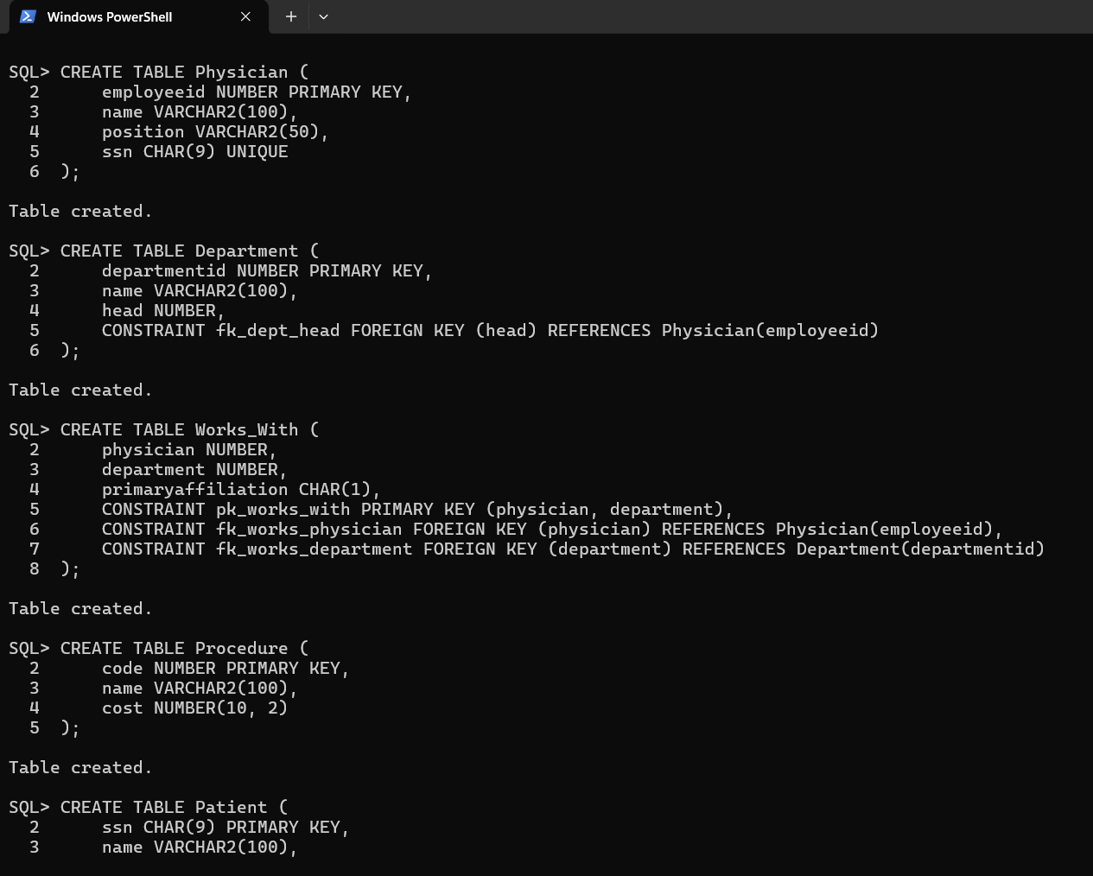

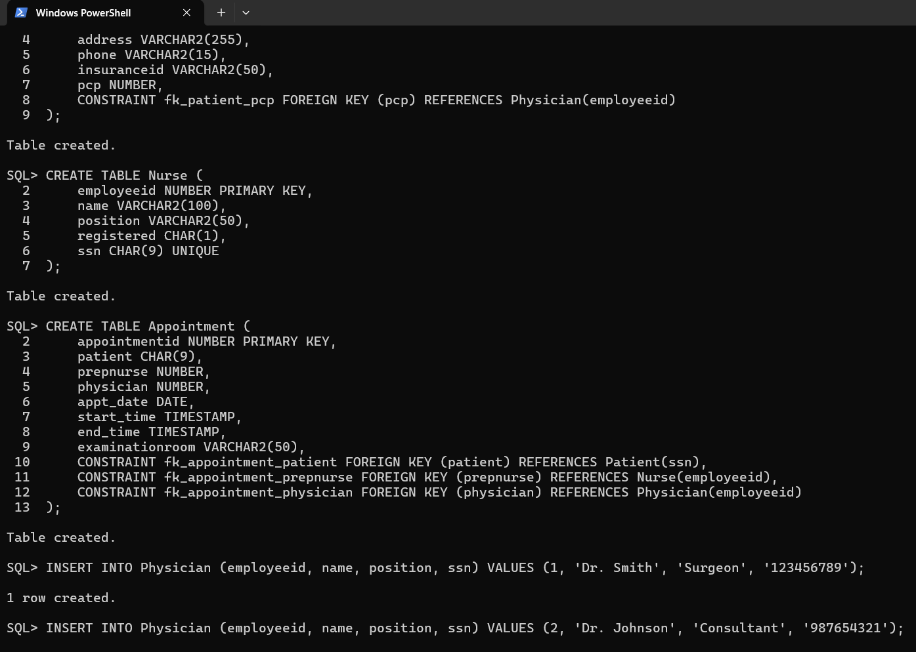  
  
  
  
  
  
  
  
  
  
  
  
  
  
  
  
  
  
  
  
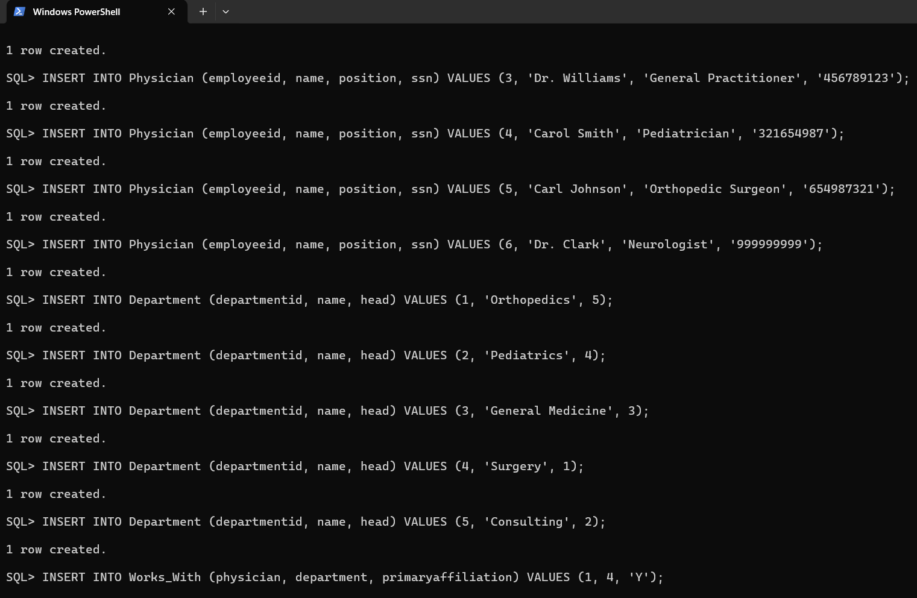

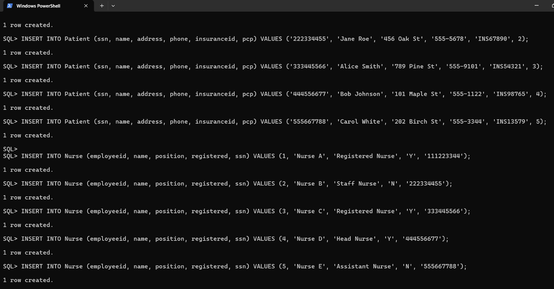

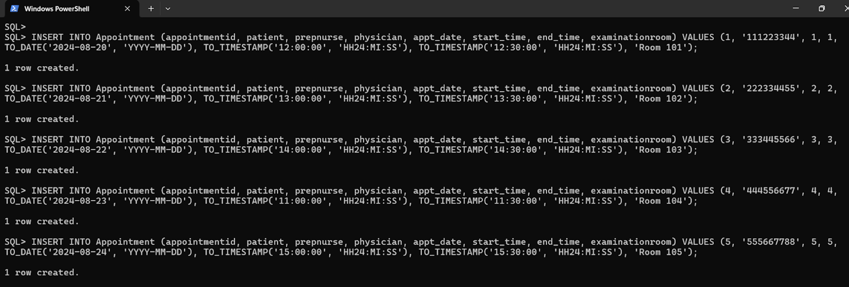

1) Write a SQL statement to display all the information of all physicians.

Queries:

SELECT * FROM Physician;

Output:

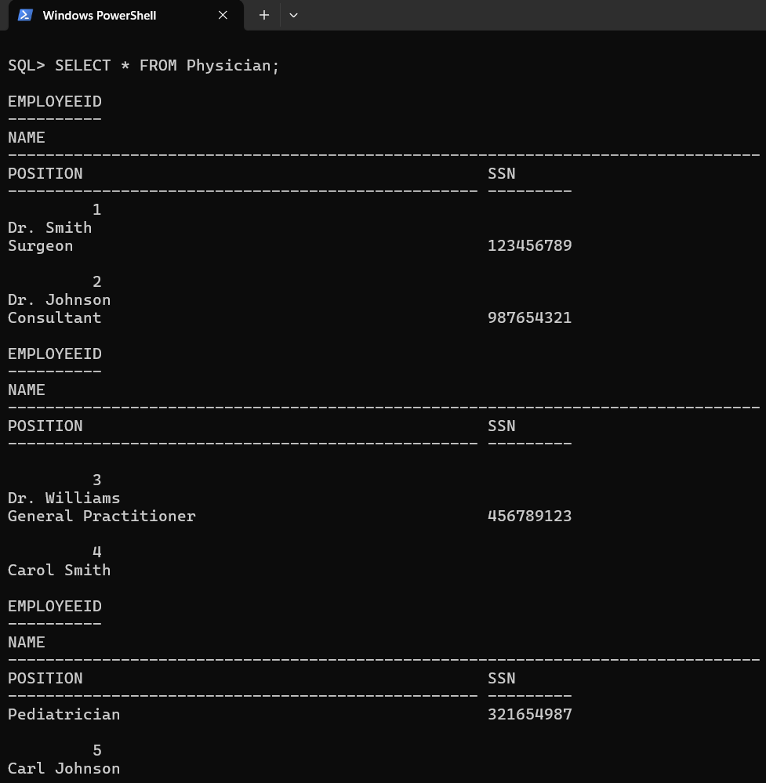

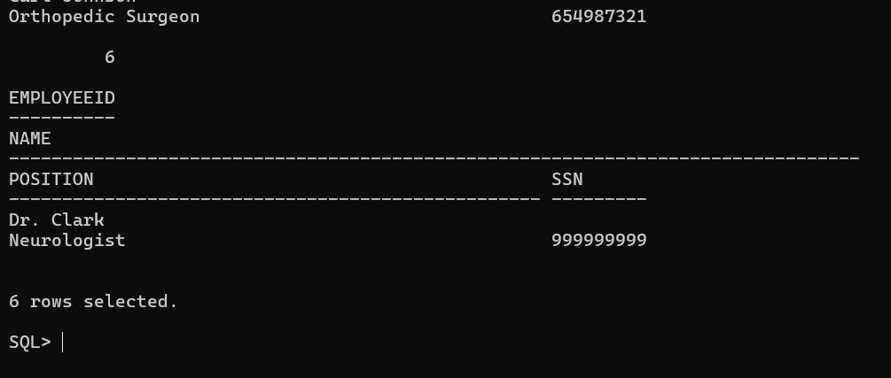

2) List the cost of medical procedure for ‘Physiotherapy’ and ‘Gastric problem’

Queries:

SELECT name, cost

FROM Procedure

WHERE name IN ('Physiotherapy', 'Gastric problem');

Output:

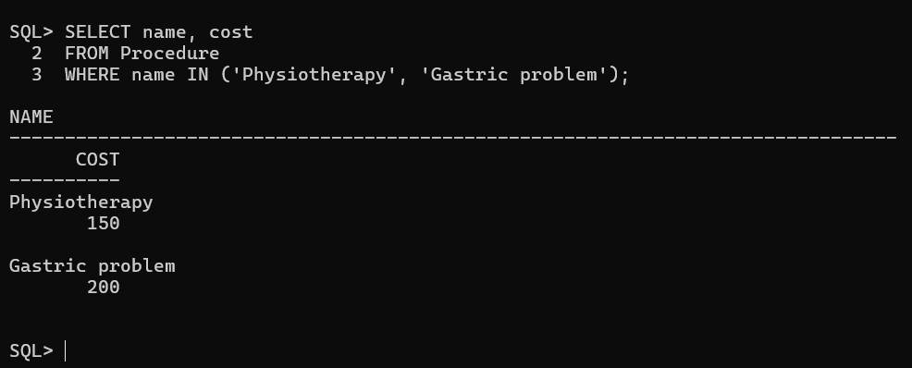

3) Find the list of the physician who does not have any affiliations. (use NULL for not affiliated)

Queries:

SELECT p.employeeid, p.name, p.position, p.ssn

FROM Physician p

LEFT JOIN Works_With w ON p.employeeid = w.physician

WHERE w.physician IS NULL;

Output:

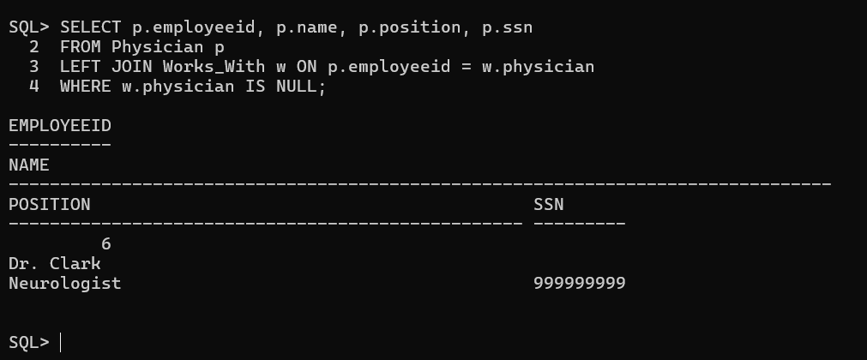

4) Write a SQL query to find the employees whose name begins with the character 'C'. Return empid, name and ssn.

Queries:

SELECT employeeid, name, ssn

FROM Physician

WHERE name LIKE 'C%';

Output:

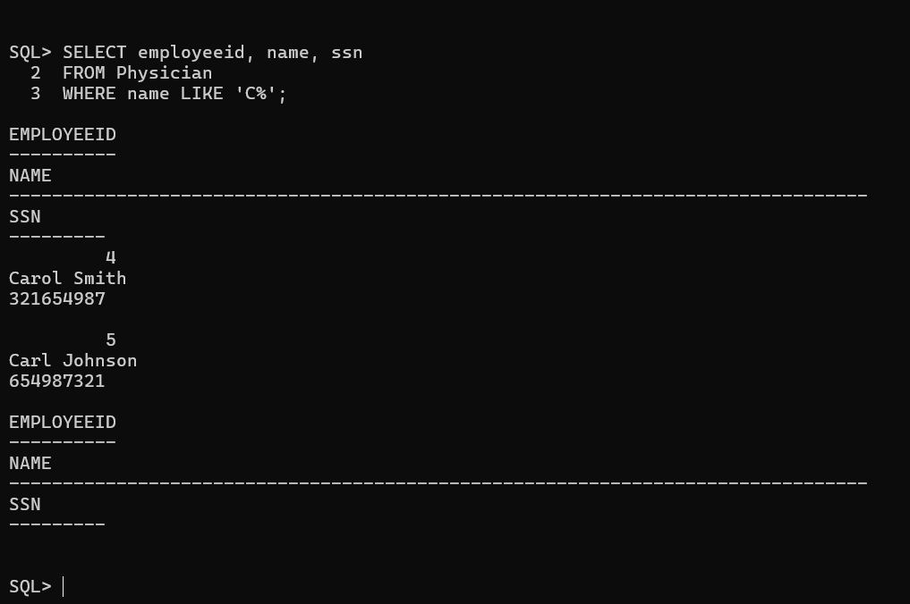

5) Write a SQL query to find the details of the patients whose appointment time is greater than 12.30 PM for a corresponding date.

Queries:

SELECT a.appointmentid, p.name, a.start_time, a.end_time, a.examinationroom

FROM Appointment a

JOIN Patient p ON a.patient = p.ssn

WHERE a.start_time > TO_TIMESTAMP('12:30:00', 'HH24:MI:SS');

Output:

